BSCS FINAL PROJECT
Requirements Specification

HASSLE-FREE: AI-POWERED CAREER ENHANCEMENT AND RECRUITMENT PLATFORM



Project Advisor

Muneeb Ali Muzaffar

Presented by:
Group ID: F25CS124

Student Reg# Student Name
L1F22BSCS0822 WALEED TARIQ
L1F22BSCS0829 M.ABDULLAH AFZAL
L1F22BSCS0841 HARIS NAEEM
L1F22BSCS0850 ALI HASSAN PERVAIZ

Faculty of Information Technology & Computer Science
University of Central Punjab
Software Requirements Specification
Version 1
HASSLE-FREE: AI-POWERED CAREER ENHANCEMENT AND RECRUITMENT PLATFORM
Advisor: Muneeb Ali Muzaffar
Group F25CS124
Member Name | Primary Responsibility
Waleed Tariq | Documentation/ Nlp Resume parsing
M.Abdullah Afzal | AI ALGORITHM & SCORING ENGINE
Haris Naeem | DEVELOPMENT(CROSS PLATFORM)
Ali Hassan Pervaiz | CLOUD DEPLOYMENT/EMPLOYEE DASHBOARD

Table of ContentsS
Table of Contents i
Revision History iii
Previous Phases Feedback iii
Abstract 1
1. Introduction and Background 1
1.1 Product (Problem Statement) 1
1.2 Background 1
1.3 Scope 2
1.4 Objective(s)/Aim(s)/Target(s) 2
1.5 Challenges 3
1.6 Learning Outcomes 3
1.7 Nature of End Product 4
1.8 Completeness Criteria 4
1.9 Business Goals 4
1.10 Related Work/ Literature Survey/ Literature Review 5
1.11 Document Conventions 5
2. Overall Description 6
2.1 Product Features 6
2.1.1 AI Resume Parsing and Tokenization 6
2.1.2 Intelligent Job Matching Engine 6
2.1.3 AI Mock Interview and Real-Time Feedback 6
2.1.4 Candidate Scoring and Badging System 6
2.1.5 Employer Dashboard for Recruitment Management 6
2.1.6 Automated Job Application Submission 7
2.2 User Classes and Characteristics 7
2.2.1 Job Seekers 7
2.2.2 Employers / Recruiters 7
2.2.3 System Administrators 7
2.3 Operating Environment 8
2.3.1 Client-Side Environment 8
2.3.2 Backend Environment 8
2.3.3 AI Processing Environment 8
2.3.4 Supported Devices 8
2.3.5 Network Requirements 9
2.4 Design and Implementation Constraints 9
2.4.1 Technical Constraints 9
2.4.2 Data Security & Privacy Constraints 9
2.4.3 Hardware Constraints 9
2.4.4 Integration Constraints 9
2.4.5 Time 9
2.5 Assumptions and Dependencies 10
2.5.1 Assumptions 10
2.5.2 Dependencies 10
3. Functional Requirements 10
3.1 Use-Case 1 Upload Resume 10
3.2 Use-Case 2 AI Mock Interview 12
3.3 Use-Case 3 Job Recommendation 13
3.4 Requirements Analysis and Modeling 15
4. Nonfunctional Requirements 18
4.1 Performance Requirements 18
4.2 Safety Requirements 18
4.3 Security Requirements 19
4.4 Additional Software Quality Attributes 19
5.Other Requirements 19
5.1 Database Requirements 19
5.2 External Interface Requirements 20
5.3 Software Interface 20
6. Revised Project Plan 21
6.1 Phase 1: Requirement & Research 21
6.2 Phase 2: Modules Development 21
6.3 Phase 3: Advanced Modules & Integration 21
6.4 Phase 4: Final Integration & Deployment 21
7. References 22
Appendix A: Glossary 23
Appendix B: IV & V Report 24

Revision History
Name | Date | Reason For Changes | Version

Previous Phases Feedback

Idea Defence Feedback (Screenshot)

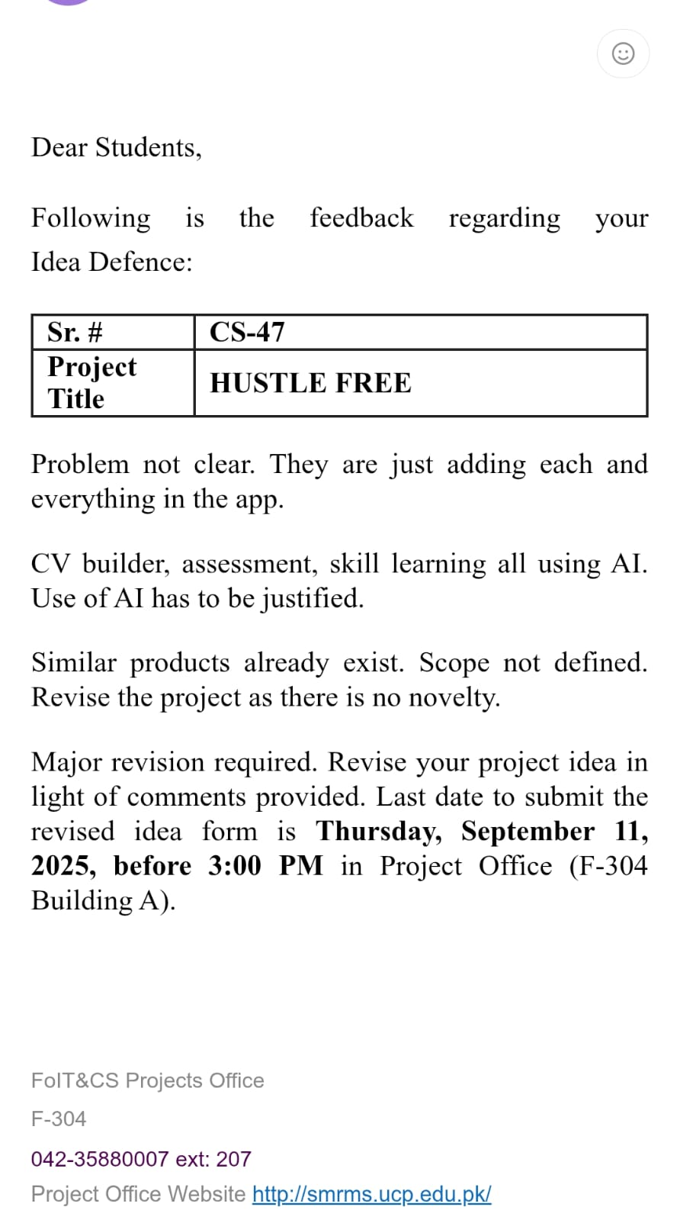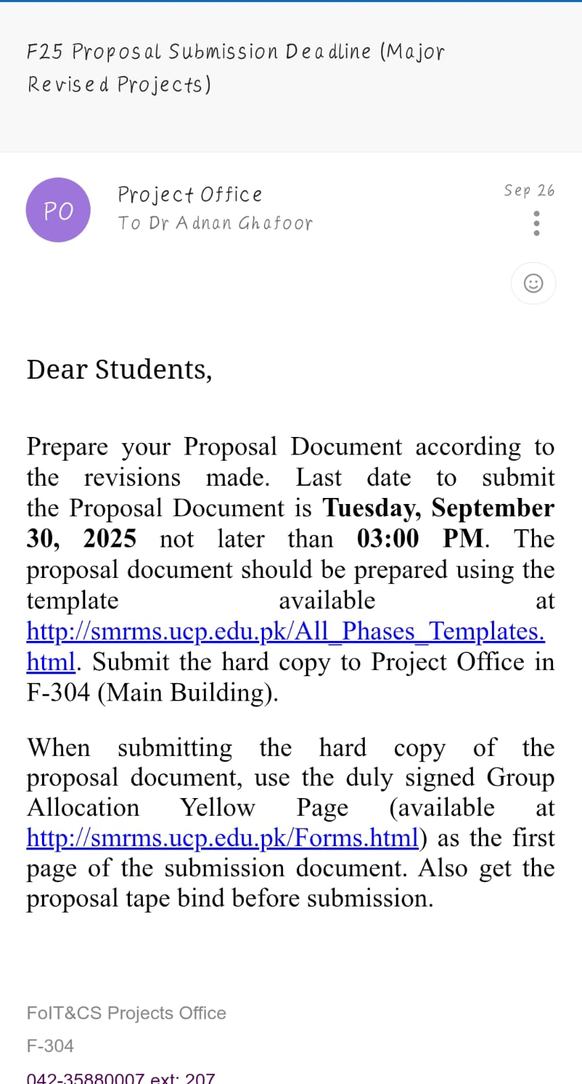

Abstract
HASSLE-FREE is an intelligent, cross-platform recruitment and career enhancement ecosystem designed to transform the interaction between job seekers and employers through AI-driven automation. Modern recruitment processes especially in developing countries often rely on manual screening, inefficient communication, and subjective candidate evaluation. HASSLE-FREE addresses these issues by integrating advanced Natural Language Processing (NLP), machine learning techniques, resume parsing, AI-based mock interviews, and smart job matching algorithms into a single unified platform.
The system enhances employability by offering comprehensive skill assessment, feedback-driven interview simulations, and automated application processes. For employers, the platform provides bias-free candidate scoring, intelligent dashboards, and data-driven decision-making tools. By bridging the gap between talent and opportunity, HASSLE-FREE aims to create a scalable, efficient, and transparent recruitment ecosystem that benefits job seekers, employers, and academic institutions alike.

Introduction and Background
HASSLE-FREE is conceptualized as a modern solution to the long-standing inefficiencies of traditional recruitment systems. In many regions, particularly in South Asia, the job market faces challenges such as manual resume screening, lack of standardized candidate evaluation, and unstructured career guidance for fresh graduates. Existing job portals primarily provide job listings without offering personalized recommendations or automated candidate assessment. On the other hand, platforms focused on skill development rarely integrate their services with job placement workflows, leaving a significant gap between learning and hiring.
This project emerges from the increasing demand for AI-powered recruitment systems that not only match candidates with suitable opportunities but also help them improve their employability through structured skill analysis and interview preparation. HASSLE-FREE combines these elements into a single ecosystem, empowering job seekers with tools for self-improvement and enabling employers to make informed hiring decisions.

Product (Problem Statement)
HASSLE-FREE is designed to address the inefficiencies of modern recruitment processes by providing a unified AI-driven platform that enables intelligent resume parsing, candidate skill evaluation, and automated job matching. The system reduces manual labor for employers, enhances accuracy in candidate shortlisting, and empowers job seekers with personalized career development guidance.

Background
The Pakistani job market—and many other developing markets—still relies on outdated, manual systems for candidate screening and job application management. Portals like Rozee.pk[1] offer basic job listings, but they lack intelligent features such as automated resume parsing, personalized recommendations, or interview simulations. Professional networking platforms like LinkedIn[2] provide visibility but do not offer localized insights or structured scoring systems. Meanwhile, platforms like HackerRank[3], Coursera[4], and Udemy[5] provide learning resources but operate independently of recruitment systems.
HASSLE-FREE is built to integrate all these fragmented functions into a single workflow using a cloud-based, AI-enabled infrastructure. It offers smart recommendations, automated parsing, and employer dashboards built specifically to address the recruitment challenges within Pakistan and similar markets.

Scope
The system encompasses a wide range of modules designed for scalability and cross-platform accessibility. The scope includes:
- Resume Parsing & NLP-based Tokenization
Automated extraction of skills, experience, education, and keywords from resumes using advanced NLP algorithms.
- Smart Job Recommendation System
Matches job seekers to relevant roles based on their skills, qualifications, and preferences using machine-learning ranking models.
- Candidate Scoring Engine
Generates employability scores and badges based on qualifications, experience, skill test results, and personality indicators.
- AI-Based Mock Interview System
Simulates real job interviews with AI-assisted questions and real-time feedback on facial expressions, tone, and content relevance.
- Employer Recruitment Dashboard
Allows employers to shortlist candidates, rank profiles, and review AI-generated scoring insights.
- Cloud-Based Deployment
Ensures scalability, reliability, and real-time synchronization across mobile and web platforms.
The project will be built as a full-stack, production-level system integrating mobile development frameworks, AI pipelines, and cloud services.

Objective(s)/Aim(s)/Target(s)
The primary objectives of the system include:
- Develop a complete AI-driven job recommendation engine using NLP to match profiles with job descriptions.
- Implement a transparent scoring and badge system to help both job seekers and employers understand candidate strengths.
- Build a real-time AI mock interview module that evaluates user responses, confidence level, communication skills, and keywords.
- Automate job applications across various portals, reducing manual effort for users.
- Provide employers with an analytical dashboard featuring charts, candidate comparisons, filtering tools, and auto-shortlisting.
These objectives directly address the limitations of existing recruitment tools and introduce modern AI solutions.

Challenges
Developing the HASSLE-FREE platform involves several technical and operational challenges:
- NLP Model Accuracy
Ensuring accurate extraction of skills, experience, and education from diverse resume formats.
- Bias-Free Scoring
Designing algorithms that avoid gender, age, ethnicity, and institutional bias during candidate evaluation.
- Multi-Module Integration
Harmonizing diverse components such as mobile apps, AI modules, databases, and dashboards into a unified workflow.
- Cloud Scalability & Security
Handling high traffic loads, protecting user data, and meeting cybersecurity standards—especially for sensitive career information.
- Real-Time Feedback in Mock Interviews
Requires optimized ML models for speech analysis, facial expression detection, and semantic understanding.

Learning Outcomes
Upon completion of this project, students will have gained:
- Knowledge of NLP and machine-learning algorithms applied in real-world recruitment systems.
- Practical experience with mobile app development frameworks (Flutter[12]/React Native[13]).
- Insights into cloud infrastructure, including deployment pipelines, scalability, and backend management.
- Skills in building multi-tier, enterprise-level systems combining AI, frontend, backend, and cloud services.
- Understanding of user experience (UX) design in job portals and professional dashboards.
- Ability to integrate and test end-to-end systems using modern DevOps practices.

Nature of End Product
The final deliverable will be a fully functional recruitment and career enhancement system, cloud-hosted and accessible through:
- A cross-platform mobile application
- A responsive web application
- A centralized backend with AI services
- A complete employer dashboard
- A real-time AI-based interview simulator
The platform will operate as a real-world prototype satisfying academic, industrial, and usability requirements.

Completeness Criteria
The project shall be considered complete when the following key modules are developed, tested, and integrated:
- Resume Parsing & Tokenization (15%)
NLP extraction of skills, experience, qualifications, and metadata.
- Mobile App Development (20%)
User authentication, profile management, job browsing, and interview modules.
- AI Algorithms (30%)
Machine-learning models for scoring, job matching, and content analysis.
- AI Mock Interview Module (15%)
Question generation, audio/video analysis, and feedback engine.
- Employer Dashboard (10%)
Candidate ranking, filters, analytics, and job posting.
- Integration, Testing & Deployment (10%)
End-to-end communication, debugging, cloud hosting, and stability checks.

Business Goals
The commercial objectives of HASSLE-FREE include:
- Reducing hiring costs for SMEs through automated screening.
- Supporting the job market by improving job seeker readiness.
- Providing Pakistan with a modern, AI-powered recruitment ecosystem.
- Offering educational institutions tools to evaluate student employability.
- Establishing a scalable model that can expand to other regions.

Related Work/ Literature Survey/ Literature Review
Several platforms served as references during the conceptual phase:
- LinkedIn[2] – Strong networking and job listing capabilities but limited automated assessment.
- Rozee.pk[1] – Local job portal focusing on listings without AI-driven guidance.
- HackerRank[3] – Provides coding assessments but lacks integration with hiring pipelines.
- Coursera[4] & Udemy[5] – Offer learning resources but do not connect directly to recruitment.
While useful, none of these systems combine AI-powered mock interviews, resume parsing, personalized employability scoring, and automated job applications in a unified ecosystem. This gap highlights the uniqueness and relevance of HASSLE-FREE.

Document Conventions
- Bold text : System modules, core components, and key features.
- Italic text : Actor roles such as job seeker, employer, administrator.
- Standard font : General descriptions, explanations, and background information.
- Numbered sections follow IEEE SRS formatting conventions.

Overall Description

Product Features
HASSLE-FREE integrates multiple AI-driven recruitment and career-development functionalities into one ecosystem. The major features include:

AI Resume Parsing and Tokenization
This feature allows the system to automatically extract structured information from resumes uploaded by job seekers. Using NLP algorithms, the system identifies educational qualifications, skills, experience, certifications, job titles, achievements, and relevant keywords. It then tokenizes and categorizes the data to create a detailed digital profile. This enables accurate scoring, better job recommendations, and improved employer filtering.

Intelligent Job Matching Engine
The system uses a combination of machine learning ranking algorithms and NLP-based semantic similarity techniques to match candidates with suitable job postings. Job descriptions are analyzed for required skills, experience levels, and domain relevance. Similarly, candidate profiles are evaluated using parsed resume content and manually entered preferences. The matching engine then assigns a compatibility score for each job, helping job seekers focus on highly relevant opportunities and enabling employers to receive more appropriate applications.

AI Mock Interview and Real-Time Feedback
This module simulates real interview scenarios using AI-generated questions based on job roles, resume data, and industry standards. The system records candidate responses and analyzes their content quality, clarity, confidence, and relevance. Additional metrics—such as speech clarity, tone modulation, and (optional) facial expression detection—provide detailed feedback. This helps users identify weaknesses and prepare more effectively for professional interviews.

Candidate Scoring and Badging System
HASSLE-FREE evaluates job seekers by calculating an employability score based on multiple factors: education history, skillset, experience, test results, interview performance, course completions, and resume strength. Candidates receive digital badges such as “Top Skilled,” “Technical Specialist,” “Highly Employable,” etc., which employers can see during shortlisting. This feature ensures transparency in evaluation and motivates users to improve their skills.

Employer Dashboard for Recruitment Management
Employers have access to a dedicated dashboard that allows them to post job openings, view recommended candidates, filter applicants based on skills/experience, and analyze AI-generated scores. The dashboard visualizes data using charts and tables, helping HR teams make informed decisions. Employers can track candidate pipelines, schedule interviews, review candidate badges, and automate shortlisting based on predefined criteria.

Automated Job Application Submission
This feature allows job seekers to apply to supported job portals automatically without manually filling out multiple forms. The system uses stored applicant information (resume, skills, education, and job preferences) to auto-fill application data. This simplifies the job search process and significantly reduces the time and effort required to apply for several positions.

User Classes and Characteristics
HASSLE-FREE is designed to support three primary user groups:

Job Seekers
These users interact with the system primarily through the mobile or web application. Typical characteristics include:
- Students, fresh graduates, and experienced professionals seeking employment.
- May not have technical knowledge, so the interface must be simple and intuitive.
- Need guidance regarding career paths, interview preparation, and skill improvement.
- Require features such as resume uploads, AI mock interviews, job suggestions, and application tracking.
- Expected to engage with scoring systems and badges for self-assessment.

Employers / Recruiters
These users represent companies searching for qualified candidates. Characteristics include:
- HR teams, hiring managers, and business owners.
- Require access to candidate profiles, scores, and analytics.
- Need efficient applicant filtering tools and automatic shortlisting based on AI ranking.
- Expect a secure, well-organized dashboard to manage job postings and communication.
- May operate in SME environments where HR resources are limited.

System Administrators
Administrators maintain the system’s backend and ensure smooth functioning. Their characteristics include:
- Technical staff responsible for managing user accounts, verifying suspicious activity, and monitoring server load.
- Require tools to view platform logs, manage AI models, and maintain data compliance.
- Ensure availability, data integrity, and security while performing system updates.

Operating Environment
HASSLE-FREE is designed to operate in a modern cross-platform environment, ensuring accessibility and responsiveness:

Client-Side Environment
- Mobile Platforms: Android (API level 23+) and iOS (iOS 12+), built using Flutter for cross-platform consistency.
- Web Interface: Responsive, browser-compatible UI supporting Chrome, Firefox, Safari, and Edge.

Backend Environment
- Firebase for Authentication, Realtime Database/Firestore, Cloud Messaging, and Storage.
- Cloud Hosting (AWS or Google Cloud):
Used to host NLP models, AI services, and the job matching algorithm. Essential services include:
  - Cloud Run / Lambda for serverless execution
  - Cloud Functions for API endpoints
  - S3 / Cloud Storage for resume and image storage

AI Processing Environment
- Python-based NLP services utilizing libraries such as spaCy[6], NLTK[7], Transformers, and scikit-learn.
- Deployed in a containerized environment such as Docker for scalability.

Supported Devices
- Smartphones (Android and iPhone)
- Tablets
- Desktop and laptop computers

Network Requirements
- Stable internet connection required for real-time job updates, mock interviews, and AI scoring.
- Offline mode may be supported for viewing saved content only.

Design and Implementation Constraints

Technical Constraints
- The mobile application must be built using Flutter[12], as mandated by project requirements.
- The backend must rely primarily on Firebase services, limiting use of external servers unless required for NLP.
- The system must integrate with cloud-hosted AI services but operate within university-licensed or open-source tools.

Data Security & Privacy Constraints
- The system must comply with international data protection principles such as GDPR-style user consent.
- Sensitive information (resumes, contact details, interview recordings) must be encrypted.
- Video and audio data must not be stored permanently without explicit consent.

Hardware Constraints
- Performance of AI mock interview features depends on device CPU and network speed.
- NLP model inference must remain lightweight enough to run in serverless environments without timeout.

Integration Constraints
- Third-party libraries (spaCy, Transformers) must be compatible with the cloud environment.
- External job portals may require API permissions or scraping limitations.

Time
- Limited development time necessitates prioritizing core AI functions.Assumptions and Dependencies

Assumptions and Dependencies

Assumptions
- Users will have stable, reliable internet access during major operations such as mock interviews or job applications.
- Job seekers will upload resumes in supported formats (PDF, DOCX, JPEG).
- Employers will provide clear job descriptions for accurate AI matching.
- Cloud services (Firebase, AWS/GCP) will remain available and functional.
- Users possess basic digital literacy to navigate mobile or web interfaces.

Dependencies
- Firebase Services: Authentication, Firestore/Realtime Database, Hosting, and Cloud Functions.
- NLP Libraries: spaCy, NLTK[7], TensorFlow/PyTorch[10] for model implementations.
- Cloud Hosting Providers: AWS or Google Cloud for AI model deployment.
- Flutter SDK[12]: Required for cross-platform app development.
- External APIs: Optional job portal APIs for automated job application submission.
- Device Features: Camera and microphone access for mock interviews.

Functional Requirements
The functional requirements define the core behavior and capabilities of the system .Focusing on interactions between job seekers, employers, and the system. This section provides a detailed description of the system’s primary functions, including uploading resumes, AI mock interviews, and intelligent job recommendations. The functional requirements are documented using detailed use-cases, with explicit preconditions, postconditions, and alternate flows to ensure all scenarios are captured.

Use-Case 1 Upload Resume
Identifier |  | UC-1
Purpose |  | Allow job seekers to upload and parse resumes for AI analysis.
Priority |  | High
Pre-conditions |  | User must be logged in.
Post-conditions |  | Resume successfully parsed and stored.
Typical Course of Action
S# | Actor Action |  | System Response
1 | User logs in to the system. |  | System verifies credentials and loads dashboard.
2 | User selects the “Upload Resume” option. |  | System opens the file upload dialog.
3 | User selects and uploads the resume file (PDF/DOCX). |  | System receives the file and validates its format.  System parses the using the NLP module, extracting education, work experience, technical skills, certifications, and other relevant details.  Parsed data is stored securely in the Firebase database, linked to the user's profile.  System displays a success notification
Alternate Course of Action
S# | Actor Action |  | System Response
1 | User uploads an invalid or corrupt file. |  | System rejects the file and shows “Invalid format or parsing failed.”
2 | User retries upload. |  | System re-validates and processes the new file.
Table 1: UC-1
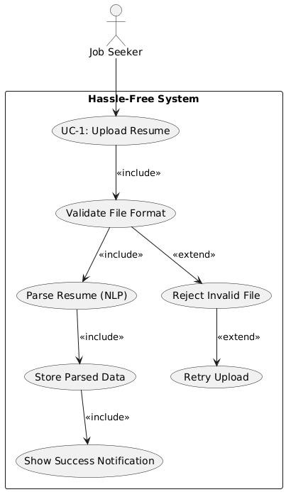
Figure UC-1

Use-Case 2 AI Mock Interview
Identifier | UC-2
Purpose | Conduct AI-based mock interview with feedback.
Priority | High
Pre-conditions | Resume parsed.
Post-conditions | Feedback stored and displayed to user.

Typical Course of Action
S# | Actor Action | System Response
1 | User selects “AI Mock Interview” from the dashboard. | System loads the mock interview interface.
2 | User starts the interview session. | System begins asking AI-generated questions based on resume and job role.
3 | User answers each question verbally or via text. | System records responses and performs NLP-based sentiment and keyword analysis.
4 | User completes the interview. | System generates a detailed performance report
  Feedback is stored in the user's profile,
Alternate Course of Action
S# | Actor Action | System Response
1 | User loses internet connection during the interview. | System pauses the interview and prompts the user to reconnect.
2 | User exits the interview early. | System saves partial data and asks for confirmation to resume later.
Table 2: UC-2

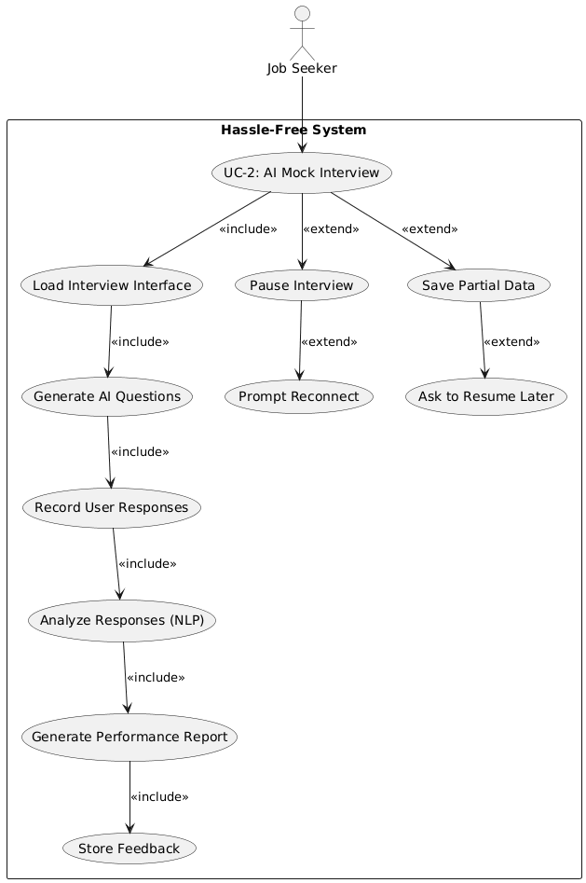
Figure UC-2

Use-Case 3 Job Recommendation
Identifier | UC-3
Purpose | Suggest best-fit jobs using NLP semantic matching.
Priority | High
Pre-conditions | Resume uploaded and parsed.
Post-conditions | Display list of recommended jobs.

Typical Course of Action
S# | Actor Action | System Response
1 | User navigates to the “Recommended Jobs” section. | System retrieves parsed resume data and skills.  NLP-based semantic matching algorithm compares the user profile against available job listings.  System ranks and filters job listings based on relevance scores, skills match, experience, and preferences.
2 | User selects a job to view details or apply. | System displays detailed job description and redirects the user to the internal application interface or external portal.
Alternate Course of Action
S# | Actor Action | System Response
1 | No suitable jobs are found. | System displays “No relevant jobs found” and suggests skill improvement courses.
2 | User updates profile and retries search. | System refreshes recommendations with new data.
Table 3: UC-3

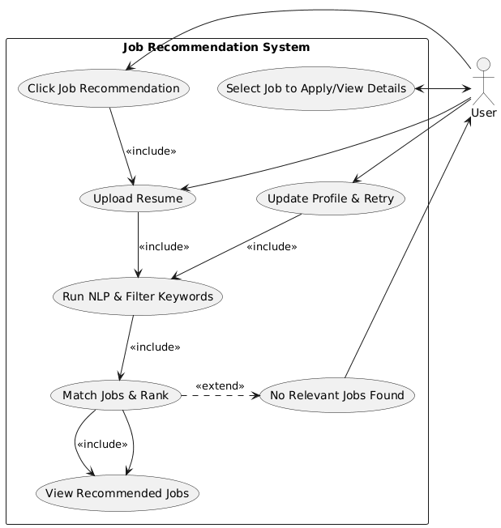

Figure UC-3

Requirements Analysis and Modeling

CLASS DIAGRAM FOR HASSLE-FREE

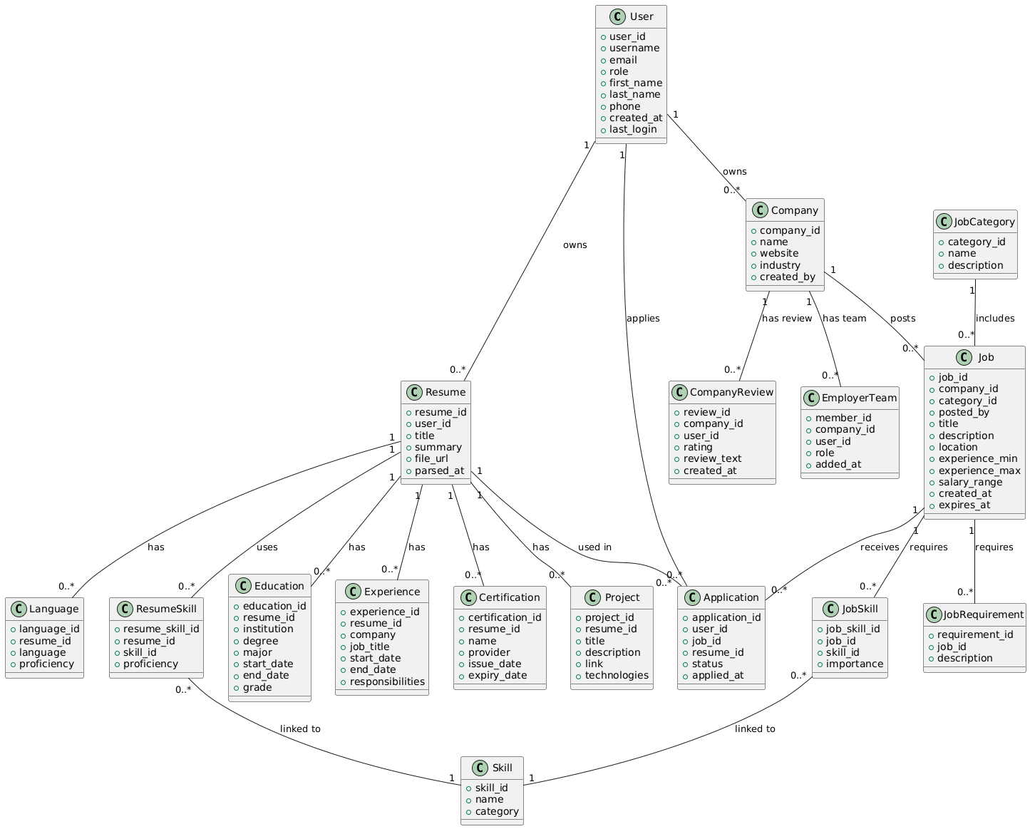

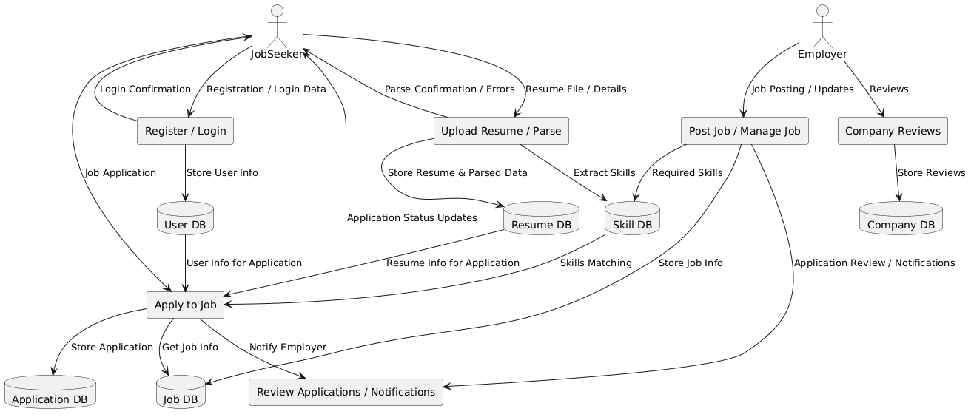

DFD LEVEL 0 DIAGRAM FOR HASSLE-FREE
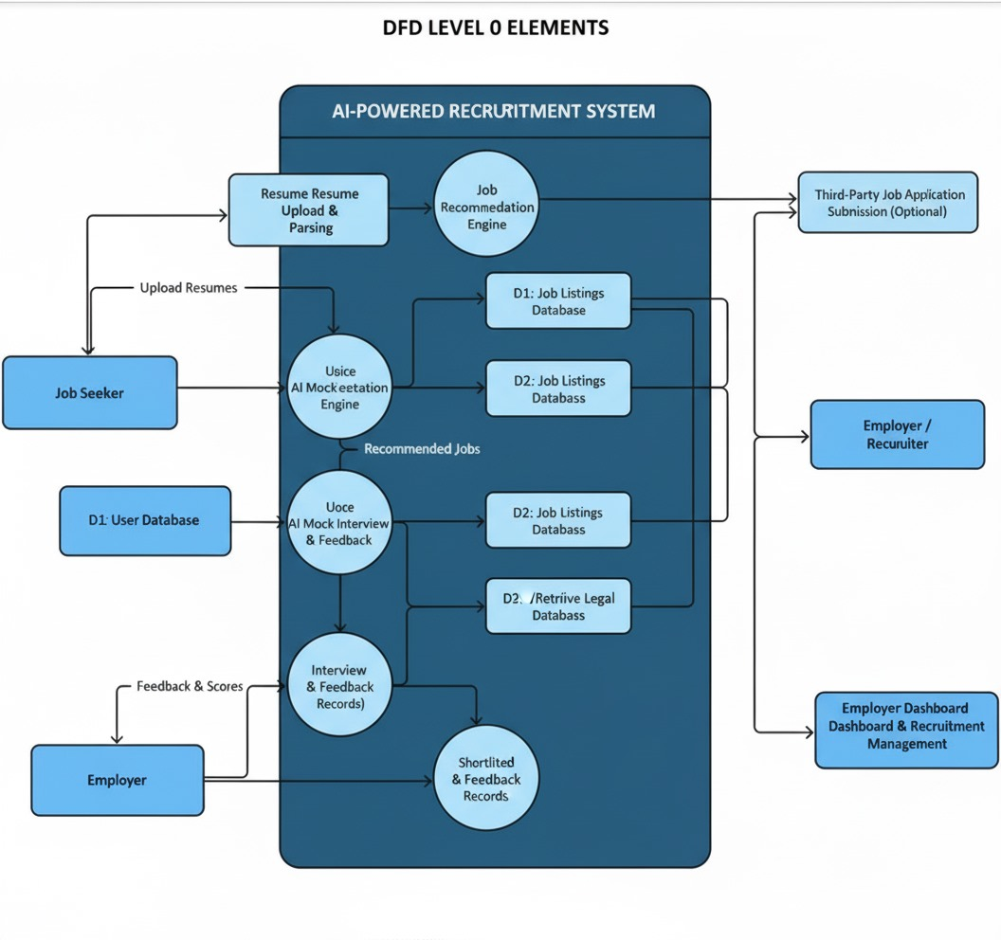

SEQUENCE DIAGRAM FOR HASSLE FREE

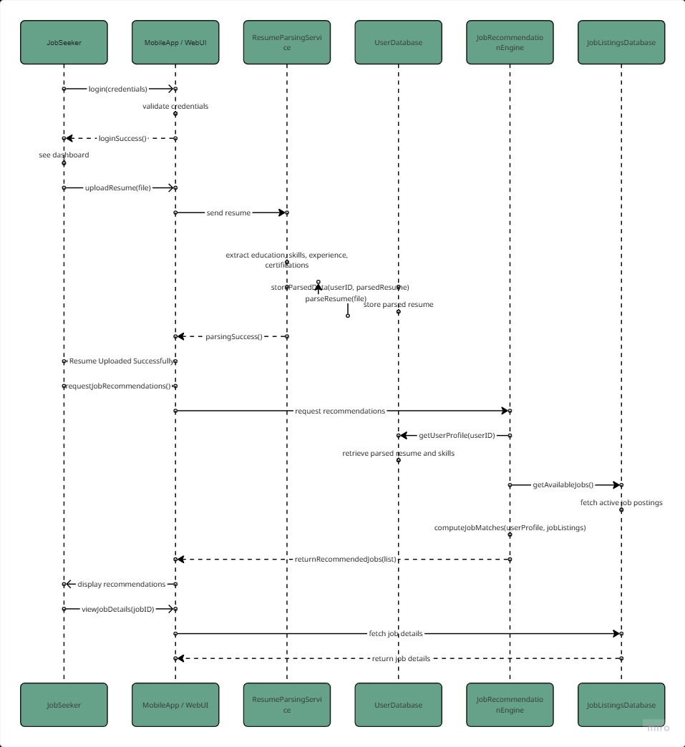

Nonfunctional Requirements
Nonfunctional requirements specify the overall qualities, performance constraints, and standards the system must adhere to, ensuring reliability, security, and usability beyond functional behavior.

Performance Requirements
The Hassle Free system shall meet the following performance criteria:
- Resume Parsing and Job Recommendation:
  - Each resume upload, parsing, and AI-based job recommendation shall be processed within 5 seconds per request under normal network conditions (4G/5G or broadband).
  - The NLP modules must handle multiple concurrent requests without performance degradation.
- AI Mock Interview Module:
  - AI-generated interview questions and feedback shall appear within 3 seconds per question, providing a responsive user experience.
- Scalability:
  - The system shall support at least 10,000 concurrent users while maintaining a response time of under 7 seconds during peak load.
- Database Operations:
  - Read/write operations to Firebase Firestore shall complete in under 2 seconds for standard queries and updates.

Safety Requirements
• Data Confidentiality:
- All user data, including resumes, interview responses, scoring results, and feedback, will be encrypted in transit and at rest using TLS/SSL and Firebase security rules.
• Error Handling & Fault Tolerance:
- The system will handle unexpected errors, invalid inputs, or network failures gracefully without crashing.
- Partially completed sessions, such as interrupted mock interviews, shall be stored securely to allow session resumption.

• Data Integrity:
- All transactional operations, such as applying to a job or updating a profile, must ensure data consistency.

Security Requirements
• Authentication and Authorization:
- Authentication is required for all users (job seekers and employers) using Firebase Authentication, including email/password or OAuth (Google, LinkedIn[2]).
- Role-based access control ensures users only access permitted modules (e.g., employers cannot access candidate interviews).
• Data Protection:
- Passwords, tokens, and sensitive user information will be encrypted using industry-standard algorithms (AES-256).
- Resume, interview, and feedback data will only be accessible to authorized system modules.
• API Security:
- All internal and external API calls (e.g., NLP modules, optional third-party integrations) will use HTTPS.
- Rate limiting and input validation will prevent abuse or unauthorized data access.

Additional Software Quality Attributes
- Reliability: The system shall maintain 99% uptime.
- Maintainability: Code will be modular, documented, and easy to update, including retraining AI models.
- Scalability: The system architecture must support horizontal scaling of AI modules and database storage.
- Usability: Interfaces shall be intuitive, responsive, and accessible on both mobile and web platforms.
- Internationalization: Future versions will support multilingual features.
- Portability: Hassle Free will run on standard Android/iOS devices and web browsers.

Other Requirements

5.1 Database Requirements
Hassle Free will use Firebase Firestore as the primary database due to scalability, real-time synchronization, and integration with Flutter[12].
- Data Storage:
  - Collections: Users, Resumes, Jobs, Applications, Interviews, Feedback.
  - Structured storage ensures efficient retrieval and update of user and job data.
- Data Security:
  - All sensitive information (passwords, interview responses, scoring results) will be encrypted.
- Data Consistency:
  - Automatic backups will prevent data loss.

5.2 External Interface Requirements

Hardware Interface
- The platform will run on any standard mobile devices (Android/iOS) and web browsers.
- Minimum client specifications:
  - Processor: Dual-Core 1.5 GHz or higher
  - Memory: 4 GB RAM
  - Storage: 200 MB free space
  - Internet: Stable internet connection

5.3 Software Interface
- Frontend Framework: Flutter
- Backend Services: Firebase Cloud Functions, Firestore, and Authentication
- AI Modules: Python-based NLP APIs (spaCy[6], Hugging Face[7], Transformers) deployed via RESTful endpoints
- Integration APIs: Optional connections with Linkedin[2], Rozee.pk[1], or company HR systems for real job postings.

6. Revised Project Plan
The Hassle Free project will be executed in four phases.

6.1 Phase 1: Requirement & Research
- Weeks: 1–7
- Tasks: Problem analysis, literature review, requirement gathering, system architecture, UML design
- Deliverables: SRS document, design diagrams

6.2 Phase 2: Modules Development
- Weeks: 8–16
- Tasks: Resume parsing & tokenization (NLP), candidate scoring & badging, job recommendation engine
- Deliverables: Resume parser, scoring system, recommendation module

6.3 Phase 3: Advanced Modules & Integration
- Weeks: 17–24
- Tasks: AI mock interview module, automated job application system, employer dashboard
- Deliverables: AI interview tool, application engine, employer dashboard

6. 4 Phase 4: Final Integration & Deployment
- Weeks: 25–32
- Tasks: System integration, testing, cloud deployment (Firebase/AWS)
- Deliverables: Fully integrated platform, testing report, final demo

GANTT CHART:
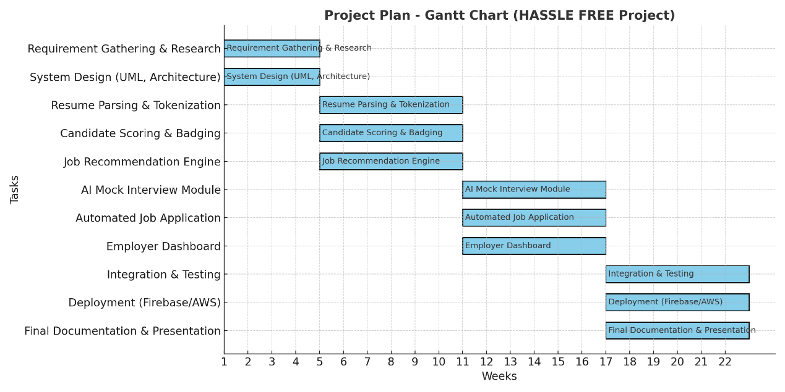

7. References
[1] Rozee.pk (2025). Pakistan’s No.1 Job Portal. https://www.rozee.pk
[2] LinkedIn (2025). Professional Networking Platform. https://www.linkedin.com
[3] HackerRank (2025). Coding & Skill Certifications. https://www.hackerrank.com
[4] Coursera (2025). Online Learning Platform. https://www.coursera.org
[5] Udemy (2025). Skill Development Platform. https://www.udemy.com
[6] spaCy (2025). Industrial-Strength Natural Language Processing Library. https://spacy.io
[7] NLTK (2025). Natural Language Toolkit for Text Processing. https://www.nltk.org
[8] HuggingFace Transformers (2025). State-of-the-Art NLP Models. https://huggingface.co
[9] scikit-learn (2025). Machine Learning Library for Python. https://scikit-learn.org
[10] PyTorch (2025). Deep Learning Framework. https://pytorch.org
[11] TensorFlow (2025). Open Source ML Platform. https://www.tensorflow.org
[12] Flutter (2025). Cross-Platform App Development Framework. https://flutter.dev
[13] React Native (2025). Cross-Platform Mobile Development Framework. https://reactnative.dev
[14] TestGorilla (2025). Pre-Employment Screening & Assessment Tools. https://www.testgorilla.com
Appendix A: Glossary
- AI: Artificial Intelligence, enabling automated decision-making and problem-solving.
- NLP: Natural Language Processing, AI techniques for analyzing and understanding human language.
- Hassle Free: AI-POWERED CAREER ENHANCEMENT AND RECRUITMENT PLATFORM
- Resume Parsing: Extracting structured information (skills, education, experience) from resumes.
- Firebase: Cloud platform providing database, authentication, and serverless services.
- Mock Interview: AI-driven simulated interview assessing candidate skills and providing feedback.
- Role-based Access Control: Security method granting permissions based on user roles.
- RESTful API: Web interface using HTTP to access and manipulate system data.
- TLS/SSL: Encryption protocols for secure data transmission.
- Recommendation Engine: AI module matching user profiles with suitable job listings.

Appendix B: IV & V Report
(Independent verification & validation)
IV & V Resource

Name Signature

S# | Defect Description | Origin Stage | Status | Fix Time
 |  |  |  | Hours | Minutes
1
2
3
…
Table 2: List of non-trivial defects

